AWS CLOUDFORMATION
Reusable Web App Templates — Parameters Lab

Student Name | Sylvain S. Kamdem
Course | UCT Cloud / DevOps Bootcamp
Instructor | Valery Nyandja
Assignment | Reusable CloudFormation Web App Templates (Parameters Lab)
AWS Region | us-east-1 (N. Virginia)
Date Submitted | June 30, 2026

1. Project Overview

This document records the completion of the Reusable CloudFormation Web App Templates lab. The objective was to deploy a web application on two different operating systems — Ubuntu Server and Windows Server — using CloudFormation templates that are made reusable through parameters. All values such as instance type, key pair, and web page content were supplied as parameters at stack creation time through the AWS Management Console, rather than being hardcoded into the template.

1.1 What Makes a Template "Reusable"?
A hardcoded template always deploys the same instance type, the same key pair, and the same web page text. If you want to change anything, you must edit the JSON file. A parameterized template instead declares inputs at the top — the Parameters section — and the person deploying the stack fills in those values in the console wizard. This means the same JSON file can be used to deploy:
- A t3.micro in development and a t3.large in production
- Different key pairs for different team members
- Different web page content per environment or per customer
- Ubuntu Server or Windows Server, simply by choosing a different AMI parameter

1.2 Lab Summary
Stack 1 | Ubuntu Server — Apache web server, web page served via UserData
Stack 2 | Windows Server — IIS web server, web page served via UserData
Parameters used | InstanceType, KeyName, WebPageContent (and AMI where applicable)
Console only | All steps performed in the AWS Management Console — no CLI
Region | us-east-1
Validation | Open WebsiteURL from stack Outputs in a browser

1.3 Parameters Used in This Lab

Parameter Name | Type | Purpose
InstanceType | String | Sets the EC2 instance size (e.g. t3.micro)
KeyName | AWS::EC2::KeyPair::KeyName | The key pair used for SSH / RDP password decryption
WebPageContent | String | The HTML text displayed on the web page
AmiId (optional) | AWS::EC2::Image::Id | Makes the AMI selectable without editing the template

2. How to Deploy a Parameterized CloudFormation Stack

The steps below are the same for both stacks. The key difference from a non-parameterized template is Step 4 — instead of skipping past the parameters screen, you fill in real values that customize the deployment.

1 | Open CloudFormation in the AWS Console  Go to Services > CloudFormation. Confirm the region is us-east-1 in the top-right selector.

2 | Click Create Stack > With new resources (standard)  This opens the Create Stack wizard.

3 | Upload the template file  Under Specify template, select Upload a template file. Click Choose file and select the correct .json template. Click Next.

4 | Fill in the parameters — this is what makes the template reusable  The Parameters screen shows all declared inputs. Fill in InstanceType, KeyName, WebPageContent, and any other parameters. These values are injected into the template at deploy time. Click Next.

5 | Accept defaults on Configure stack options  Leave all options at their defaults. Click Next.

6 | Review and Submit  Review the parameter values shown in the summary. Click Submit. Status shows CREATE_IN_PROGRESS.

7 | Wait for CREATE_COMPLETE  Refresh the Events tab until the status shows CREATE_COMPLETE (1-3 min Linux, 5-10 min Windows).

8 | Validate via the Outputs tab  Click the Outputs tab and open the WebsiteURL. The page should display the custom content you supplied as a parameter.

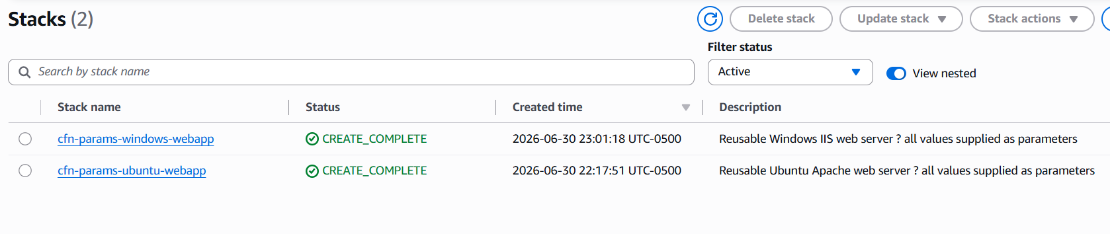

3. Stack 1 — Ubuntu Server Web App

⚙ Ubuntu 22.04 LTS — Apache Web Server — Deployed via CloudFormation Parameters

This stack provisions an Ubuntu EC2 instance. A UserData shell script installs Apache and writes a custom HTML page whose content is pulled directly from the WebPageContent parameter value supplied during stack creation.

3.1 CloudFormation Template (JSON)
The following JSON template was used for the Ubuntu stack. Notice the Parameters section at the top — all customizable values are declared here, and referenced later using { "Ref": "ParameterName" }.

{
"AWSTemplateFormatVersion": "2010-09-09",
"Description": "Reusable Ubuntu Apache web server — all values supplied as parameters",

"Parameters": {
"InstanceType": {
"Type": "String",
"Default": "t3.micro",
"AllowedValues": ["t2.micro", "t3.micro", "t3.small"],
"Description": "EC2 instance size"
},
"KeyName": {
"Type": "AWS::EC2::KeyPair::KeyName",
"Description": "Existing EC2 key pair for SSH access"
},
"WebPageContent": {
"Type": "String",
"Default": "Hello from CloudFormation! Im Sim’s.",
"Description": "Text displayed on the web page"
}
},

"Resources": {
"UbuntuSG": {
"Type": "AWS::EC2::SecurityGroup",
"Properties": {
"GroupDescription": "Allow HTTP and SSH",
"SecurityGroupIngress": [
{ "IpProtocol":"tcp","FromPort":80,"ToPort":80,"CidrIp":"0.0.0.0/0" },
{ "IpProtocol":"tcp","FromPort":22,"ToPort":22,"CidrIp":"0.0.0.0/0" }
]
}
},
"UbuntuInstance": {
"Type": "AWS::EC2::Instance",
"Properties": {
"InstanceType": { "Ref": "InstanceType" },
"ImageId": " ami-0c02fb55956c7d316",
"KeyName": { "Ref": "KeyName" },
"SecurityGroups": [{ "Ref": "UbuntuSG" }],
"UserData": {
"Fn::Base64": { "Fn::Join": ["", [
"#!/bin/bash\n",
"yum update -y\n",
"yum install -y httpd\n",
"systemctl start httpd\n",
"systemctl enable httpd\n",
"echo '<html><body><h1>", { "Ref": "WebPageContent" }, "</h1></body></html>'",
" > /var/www/html/index.html\n"
]]}
}
}
}
},

"Outputs": {
"WebsiteURL": {
"Value": { "Fn::Join": ["", ["http://",
{ "Fn::GetAtt": ["UbuntuInstance","PublicDnsName"] }]] },
"Description": "URL of the web application"
}
}
}

3.2 Parameters Supplied at Stack Creation
Stack Name | cfn-params-ubuntu-webapp
InstanceType | t3.micro
KeyName | my-keypair-name
WebPageContent | Hello from CloudFormation! I am Sims.
AMI | Ubuntu Server 22.04 LTS — ami-0c7217cdde317cfec (us-east-1)
Security Group | HTTP port 80 open to 0.0.0.0/0; SSH port 22 open to 0.0.0.0/0
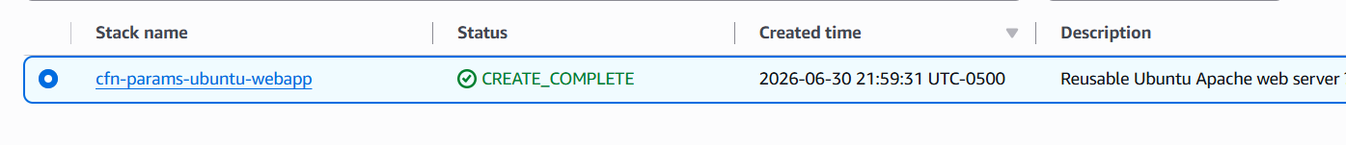
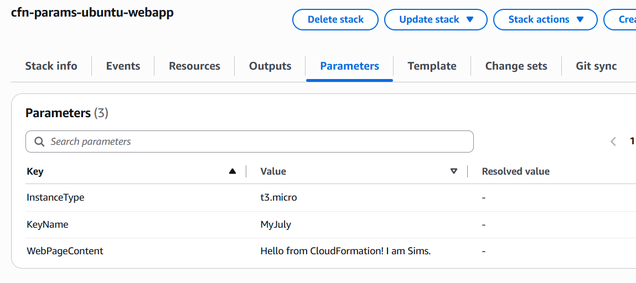

3.3 How UserData Uses the Parameter
The WebPageContent parameter value flows into the running instance through the UserData script. CloudFormation substitutes the Ref at deploy time, so the script that runs on the EC2 instance looks like this:
#!/bin/bash
apt-get update -y
apt-get install -y apache2
systemctl start apache2
systemctl enable apache2
echo '<html><body><h1>Hello from CloudFormation! I am Sims</h1></body></html>' > /var/www/html/index.html

📝 Note: The text in bold above is exactly what was typed into the WebPageContent parameter field in the console. Changing that value and re-deploying the stack would produce a different page — no template editing required.

3.4 Validation — WebsiteURL in Browser
After the stack reached CREATE_COMPLETE, the WebsiteURL was copied from the Outputs tab and opened in a browser. The page displayed the custom web page content supplied as a parameter.

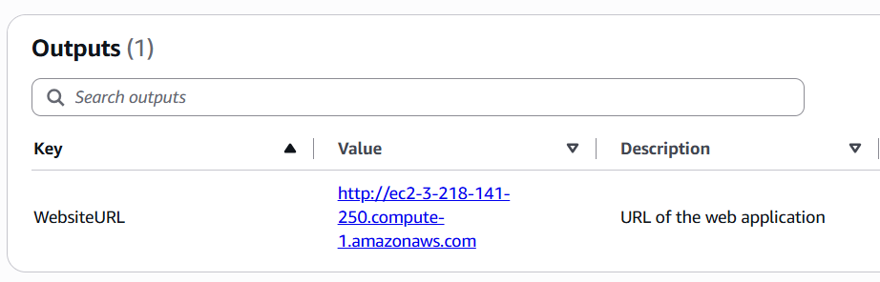

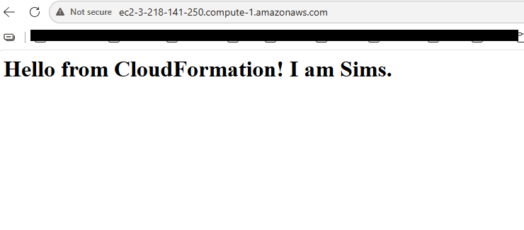

4. Stack 2 — Windows Server Web App

⚙ Windows Server 2022 — IIS Web Server — Deployed via CloudFormation Parameters

This stack provisions a Windows Server EC2 instance. A PowerShell-based UserData script installs IIS and writes a custom HTML page whose content is drawn from the WebPageContent parameter. The same JSON template structure is used — only the AMI ID and the UserData script language (PowerShell instead of bash) differ from the Ubuntu template.

4.1 CloudFormation Template (JSON)
{
"AWSTemplateFormatVersion": "2010-09-09",
"Description": "Reusable Windows IIS web server — all values supplied as parameters",

"Parameters": {
"InstanceType": {
"Type": "String",
"Default": "t3.small",
"AllowedValues": ["t3.small", "t3.medium"],
"Description": "EC2 instance size (Windows needs at least t3.small)"
},
"KeyName": {
"Type": "AWS::EC2::KeyPair::KeyName",
"Description": "Existing EC2 key pair (used to decrypt Windows password)"
},
"WebPageContent": {
"Type": "String",
"Default": "Hello from CloudFormation!I a Sims.",
"Description": "Text displayed on the IIS web page"
}
},

"Resources": {
"WindowsSG": {
"Type": "AWS::EC2::SecurityGroup",
"Properties": {
"GroupDescription": "Allow HTTP",
"SecurityGroupIngress": [
{ "IpProtocol":"tcp","FromPort":80,"ToPort":80,"CidrIp":"0.0.0.0/0" }
]
}
},
"WindowsInstance": {
"Type": "AWS::EC2::Instance",
"Properties": {
"InstanceType": { "Ref": "InstanceType" },
"ImageId": "ami-09639480113b0df96",
"KeyName": { "Ref": "KeyName" },
"SecurityGroups": [{ "Ref": "WindowsSG" }],
"UserData": {
"Fn::Base64": { "Fn::Join": ["", [
"<powershell>\nInstall-WindowsFeature -Name Web-Server -IncludeManagementTools\n",
"$content = '<html><body><h1>", { "Ref": "WebPageContent" }, "</h1></body></html>'\n",
"Set-Content -Path C:\\inetpub\\wwwroot\\iisstart.htm -Value $content\n",
"</powershell>"
]]}
}
}
}
},

"Outputs": {
"WebsiteURL": {
"Value": { "Fn::Join": ["", ["http://",
{ "Fn::GetAtt": ["WindowsInstance","PublicDnsName"] }]] },
"Description": "URL of the IIS web application"
}
}
}

4.2 Parameters Supplied at Stack Creation
Stack Name | cfn-params-windows-webapp
InstanceType | t3.small
KeyName | [my-keypair-name]
WebPageContent | Hello from CloudFormation! I am Sims.
AMI | Windows Server 2022 Base — ami-0f9c44e98edf38a2b (us-east-1)
Security Group | HTTP port 80 open to 0.0.0.0/0

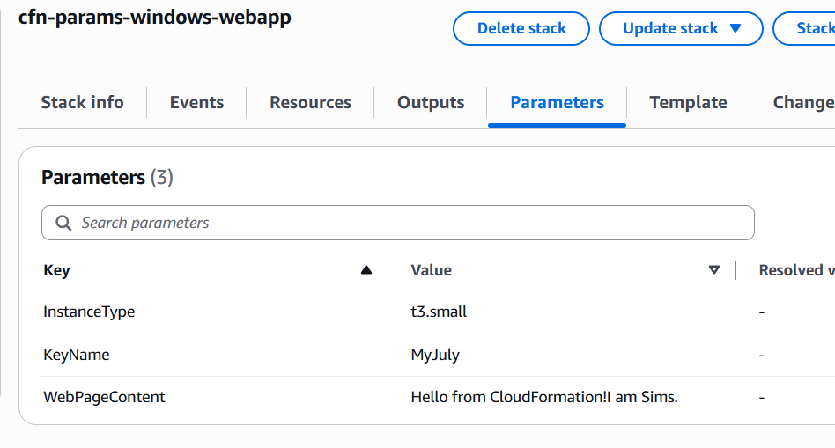

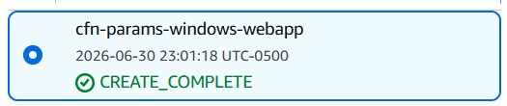

4.3 How UserData Uses the Parameter (PowerShell)
The PowerShell script that runs on first boot with the WebPageContent value substituted looks like this:
<powershell>
Install-WindowsFeature -Name Web-Server -IncludeManagementTools
$content = '<html><body><h1>Hello from CloudFormation! I am Sims.</h1></body></html>'
Set-Content -Path C:\inetpub\wwwroot\iisstart.htm -Value $content
</powershell>

📝 Note: Windows UserData uses <powershell> tags instead of #!/bin/bash. The EC2Launch v2 agent detects these tags and runs the script as PowerShell on first boot. IIS installation can take 5-8 minutes after the instance reaches running state.

4.4 Validation — WebsiteURL in Browser
After the stack reached CREATE_COMPLETE and IIS finished installing (approximately 5-8 minutes after CREATE_COMPLETE), the WebsiteURL was opened from the Outputs tab. The page displayed the custom content supplied as a parameter.

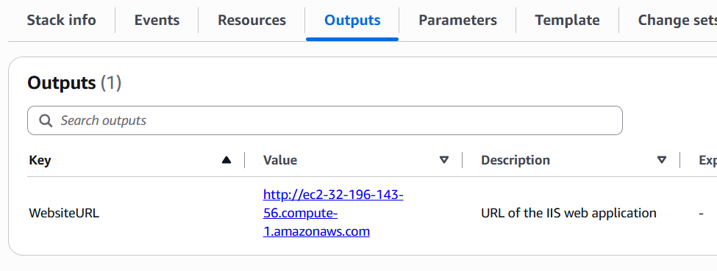

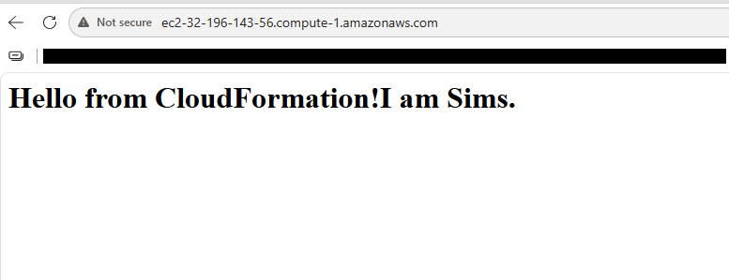

5. Ubuntu vs Windows — Side-by-Side Comparison

Aspect | Ubuntu Stack | Windows Stack
Stack name | cfn-params-ubuntu-webapp | cfn-params-windows-webapp
OS | Ubuntu Server 22.04 LTS | Windows Server 2022
Web server | Apache2 (httpd) | IIS (Web-Server feature)
UserData language | Bash shell script | PowerShell (<powershell> tags)
Install command | yum install -y httpd | Install-WindowsFeature Web-Server
Web root path | /var/www/html/index.html | C:\inetpub\wwwroot\iisstart.htm
InstanceType used | t3.micro | t3.small
Time to complete | ~2 minutes | ~8-10 minutes
Parameters shared | InstanceType, KeyName, WebPageContent | InstanceType, KeyName, WebPageContent
Validation method | WebsiteURL in browser | WebsiteURL in browser

6. Key CloudFormation Concepts

Concept | Explanation
Parameters | The Parameters section at the top of a template declares all the inputs the user can supply at deploy time. Each parameter has a Type, optional Default, optional AllowedValues, and a Description shown in the console.
Ref | { "Ref": "ParameterName" } is how a template reads a parameter value and inserts it into a resource property. The same syntax also references other resources in the template.
Fn::Join | Concatenates a list of strings into one. Used in UserData to build the full shell script by joining static lines with the dynamic parameter value (WebPageContent).
Fn::Base64 | Base64-encodes the UserData script. EC2 requires UserData to be Base64-encoded — CloudFormation handles this automatically with this function.
Fn::GetAtt | Retrieves an attribute of a resource after it is created, such as the PublicDnsName of an EC2 instance, which is used to build the WebsiteURL output.
Outputs | The Outputs section exposes values from the stack after creation — such as the WebsiteURL — visible in the Outputs tab of the CloudFormation console and consumable by other stacks.
AllowedValues | An optional constraint on a parameter that restricts the choices to a defined list. CloudFormation validates the supplied value against this list before creating the stack.
Default | A parameter Default value is pre-filled in the console parameters screen. The user can accept it or override it. It makes templates more beginner-friendly.

7. AWS Resource Summary

The table below lists every resource created during this lab. All resources are in the us-east-1 region and follow the assignment naming convention.

Resource Type | Name / ID | Notes
CF Stack | cfn-params-ubuntu-webapp | Ubuntu Apache — CREATE_COMPLETE
EC2 Instance | Ubuntu t3.micro | Terminated after validation
Security Group | UbuntuSG (auto-named) | HTTP 80 + SSH 22
CF Stack | cfn-params-windows-webapp | Windows IIS — CREATE_COMPLETE
EC2 Instance | Windows t3.small | Terminated after validation
Security Group | WindowsSG (auto-named) | HTTP 80 only
Key Pair | [your-keypair-name] | Used for both stacks

8. Lessons Learned

- Parameters are what make CloudFormation templates truly reusable. The same template can deploy to dev, staging, and production simply by supplying different parameter values — no file editing, no duplication of templates.
- AllowedValues adds safety. Restricting InstanceType to a list of approved sizes prevents accidental deployment of expensive instance types, which is a best practice in team and production environments.
- UserData + Ref is a powerful combination. Being able to inject a parameter value directly into a shell or PowerShell script means that infrastructure and application content can be customized at the same time, in the same stack deployment.
- Windows requires more time and a larger instance. Windows stacks consistently take longer to create and need at least t3.small to avoid performance issues, while Ubuntu works fine on t3.micro. Knowing this upfront avoids troubleshooting delays.
- Outputs make stacks self-documenting. Instead of hunting for the IP address in EC2, the WebsiteURL in the Outputs tab gives a ready-to-use link immediately after the stack completes — the intended handoff mechanism for CloudFormation-deployed applications.

9. Conclusion

Both stacks were successfully deployed and validated. The Ubuntu stack deployed an Apache web server using a bash UserData script, and the Windows stack deployed an IIS web server using a PowerShell UserData script. In both cases, the web page content was supplied as a parameter at deploy time — demonstrating that the same template can produce different results without any changes to the JSON file.

This lab reinforced a core Infrastructure as Code principle: separate configuration from code. The template defines the infrastructure structure; the parameters carry the values. This separation is what makes CloudFormation templates reusable across environments, teams, and use cases.

